How do archaeologists write about race? Computational text analysis of 40 years of Society of American Archaeology Annual Meeting Abstracts.

Myfirstname Mylastname1,✉, and Yourfirstname Yourlastname2

20 June, 2021

Text of abstract

1 University of One Place  
2 University of Another Place

✉ Correspondence: [Myfirstname Mylastname <[fl@oneplace.edu](mailto:fl@oneplace.edu)>](mailto:fl@oneplace.edu)

Keywords: keyword 1; keyword 2; keyword 3

Highlights: These are the highlights

knitr::include_graphics(here::here("analysis/figures/001-keyword-time-series.jpg"))

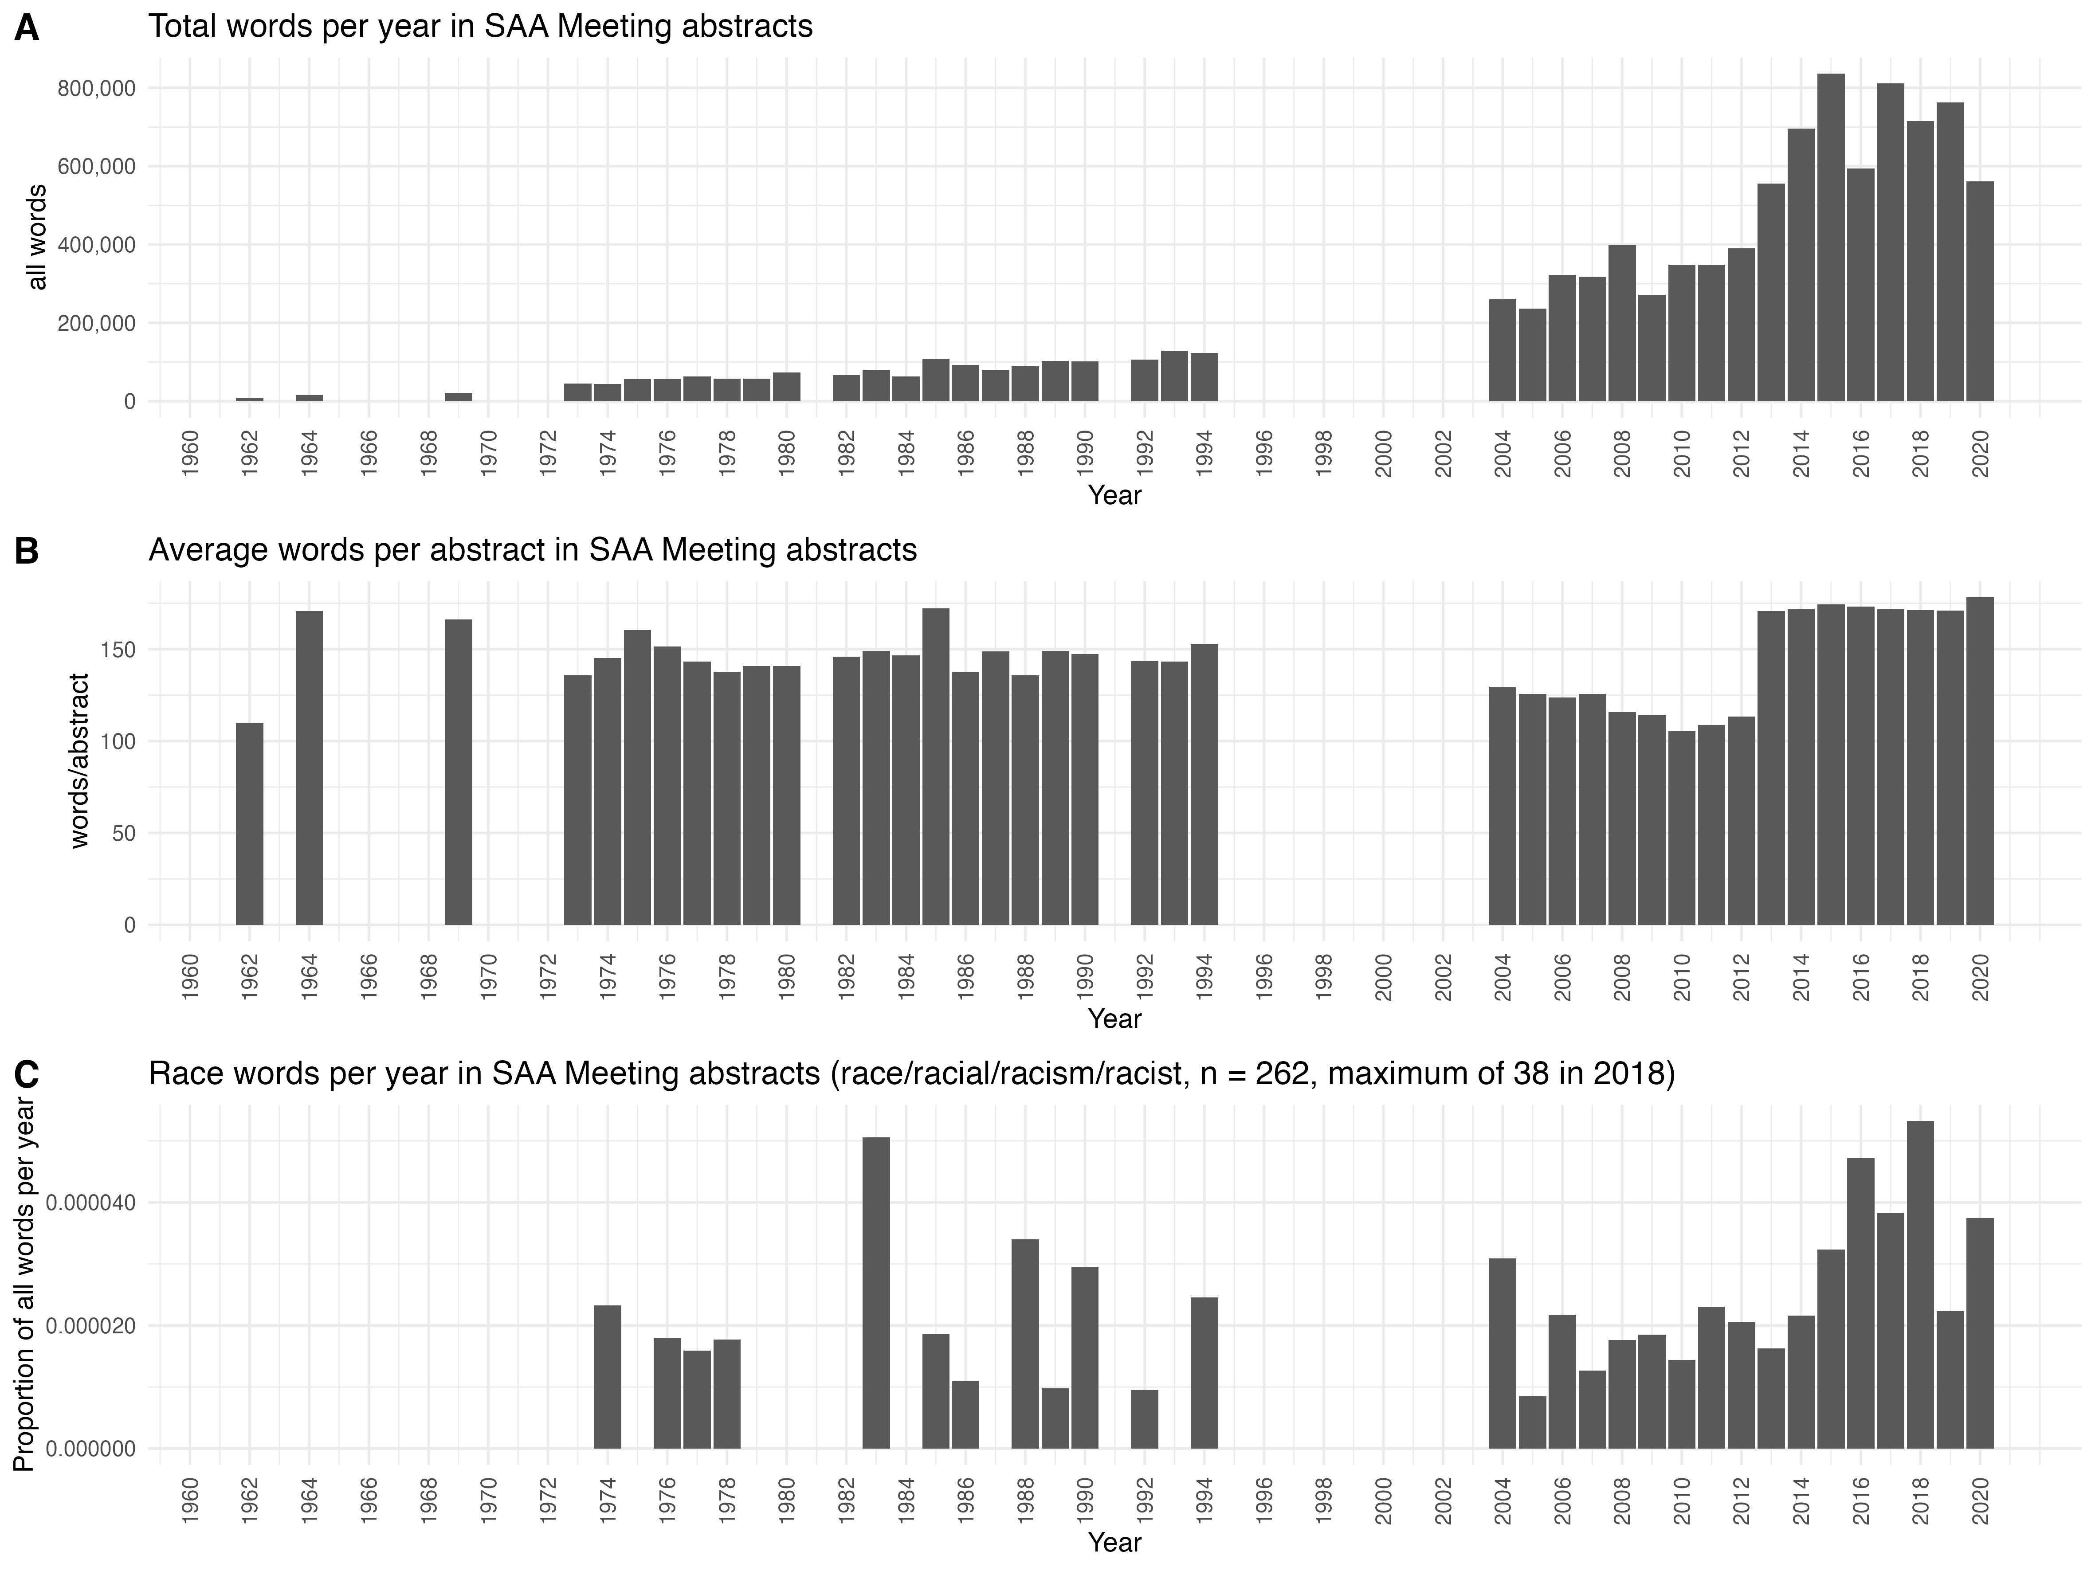

knitr::include_graphics(here::here("analysis/figures/002-topic-model.jpg"))

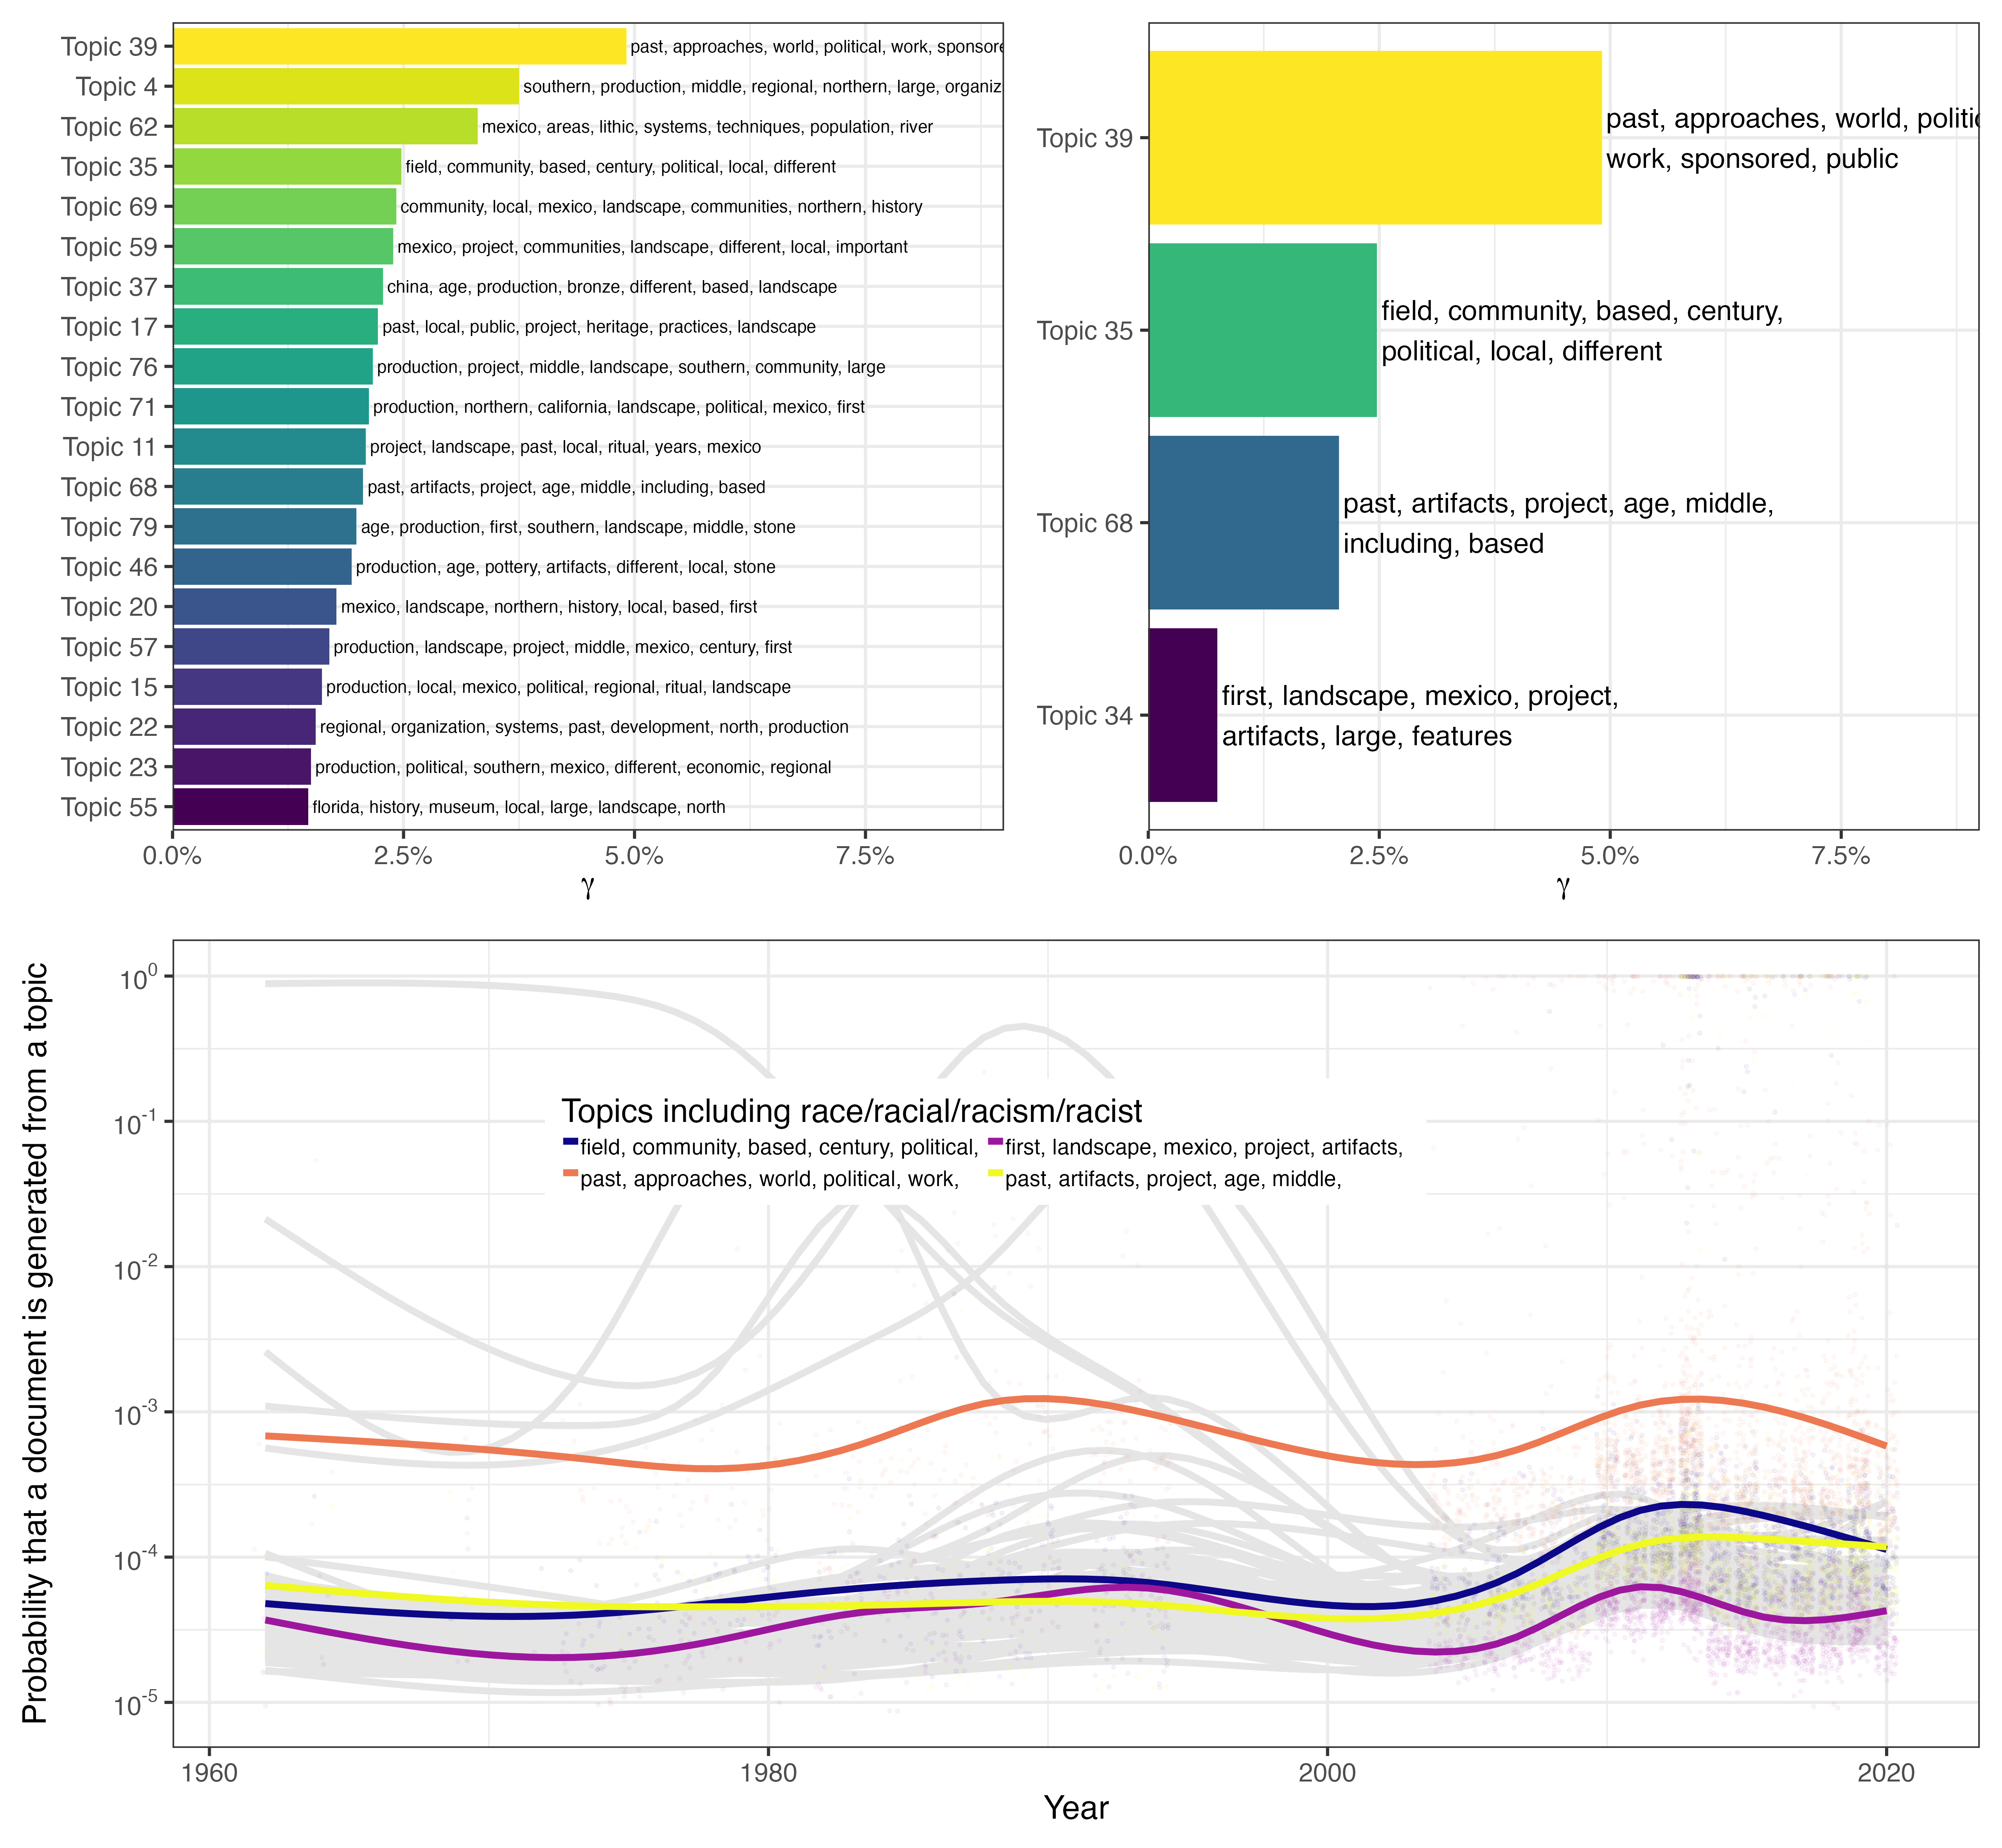

knitr::include_graphics(here::here("analysis/figures/003-keyword-similar-words.jpg"))

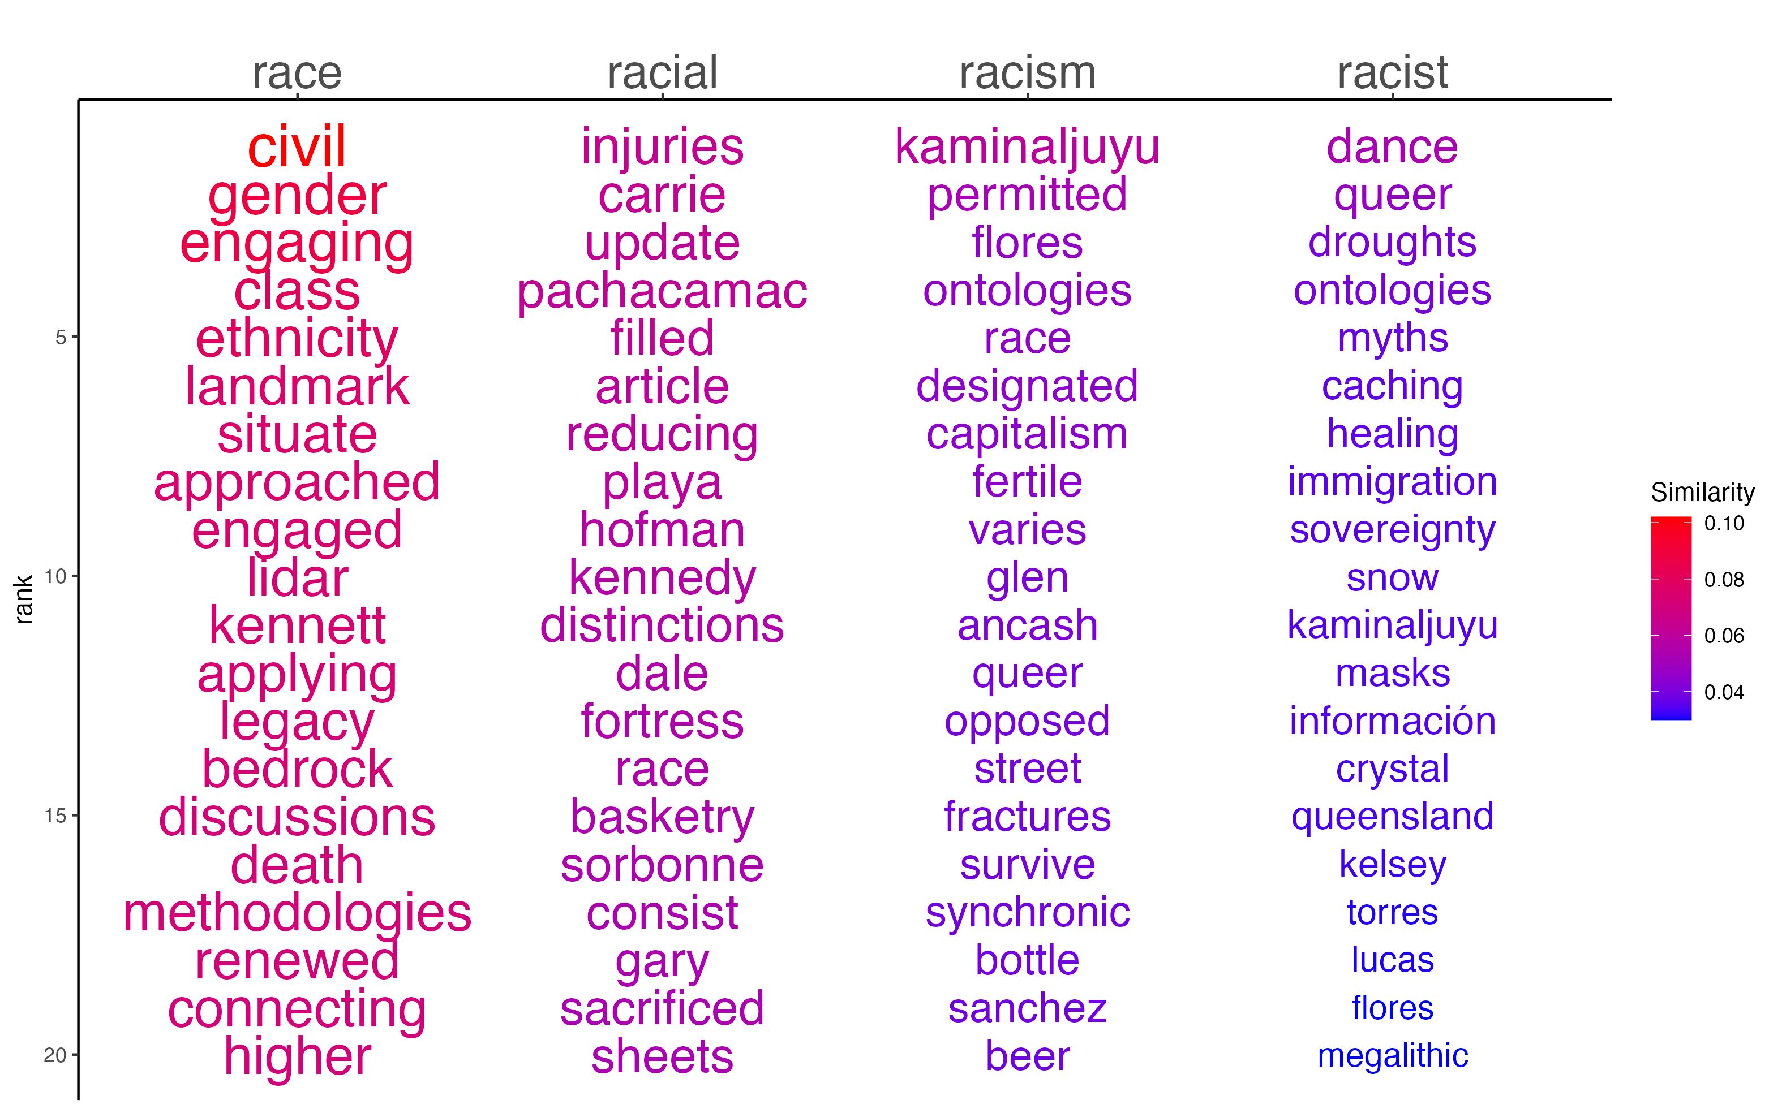

knitr::include_graphics(here::here("analysis/figures/004-keyword-kwic.jpg"))

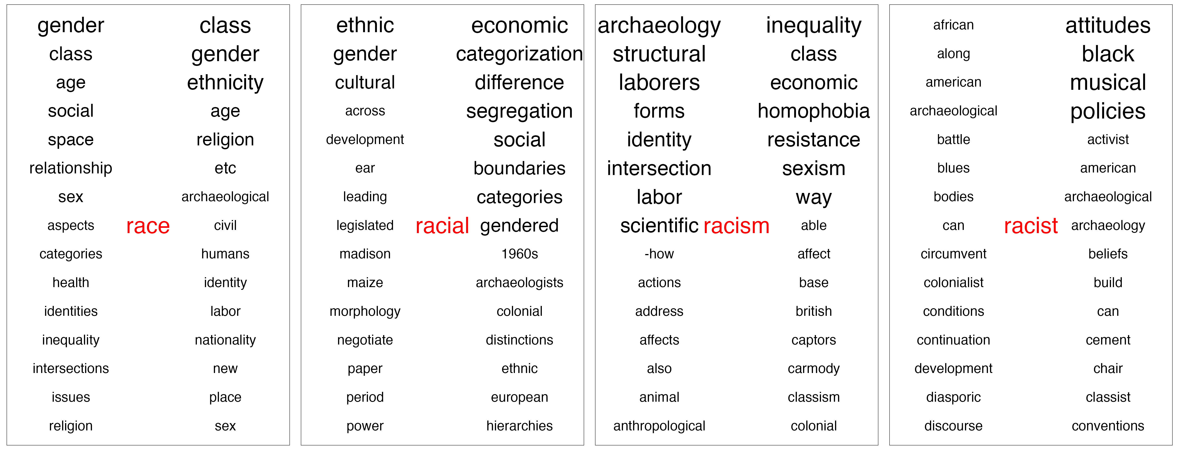

knitr::include_graphics(here::here("analysis/figures/005-keyword-and-event-relationships.jpg"))

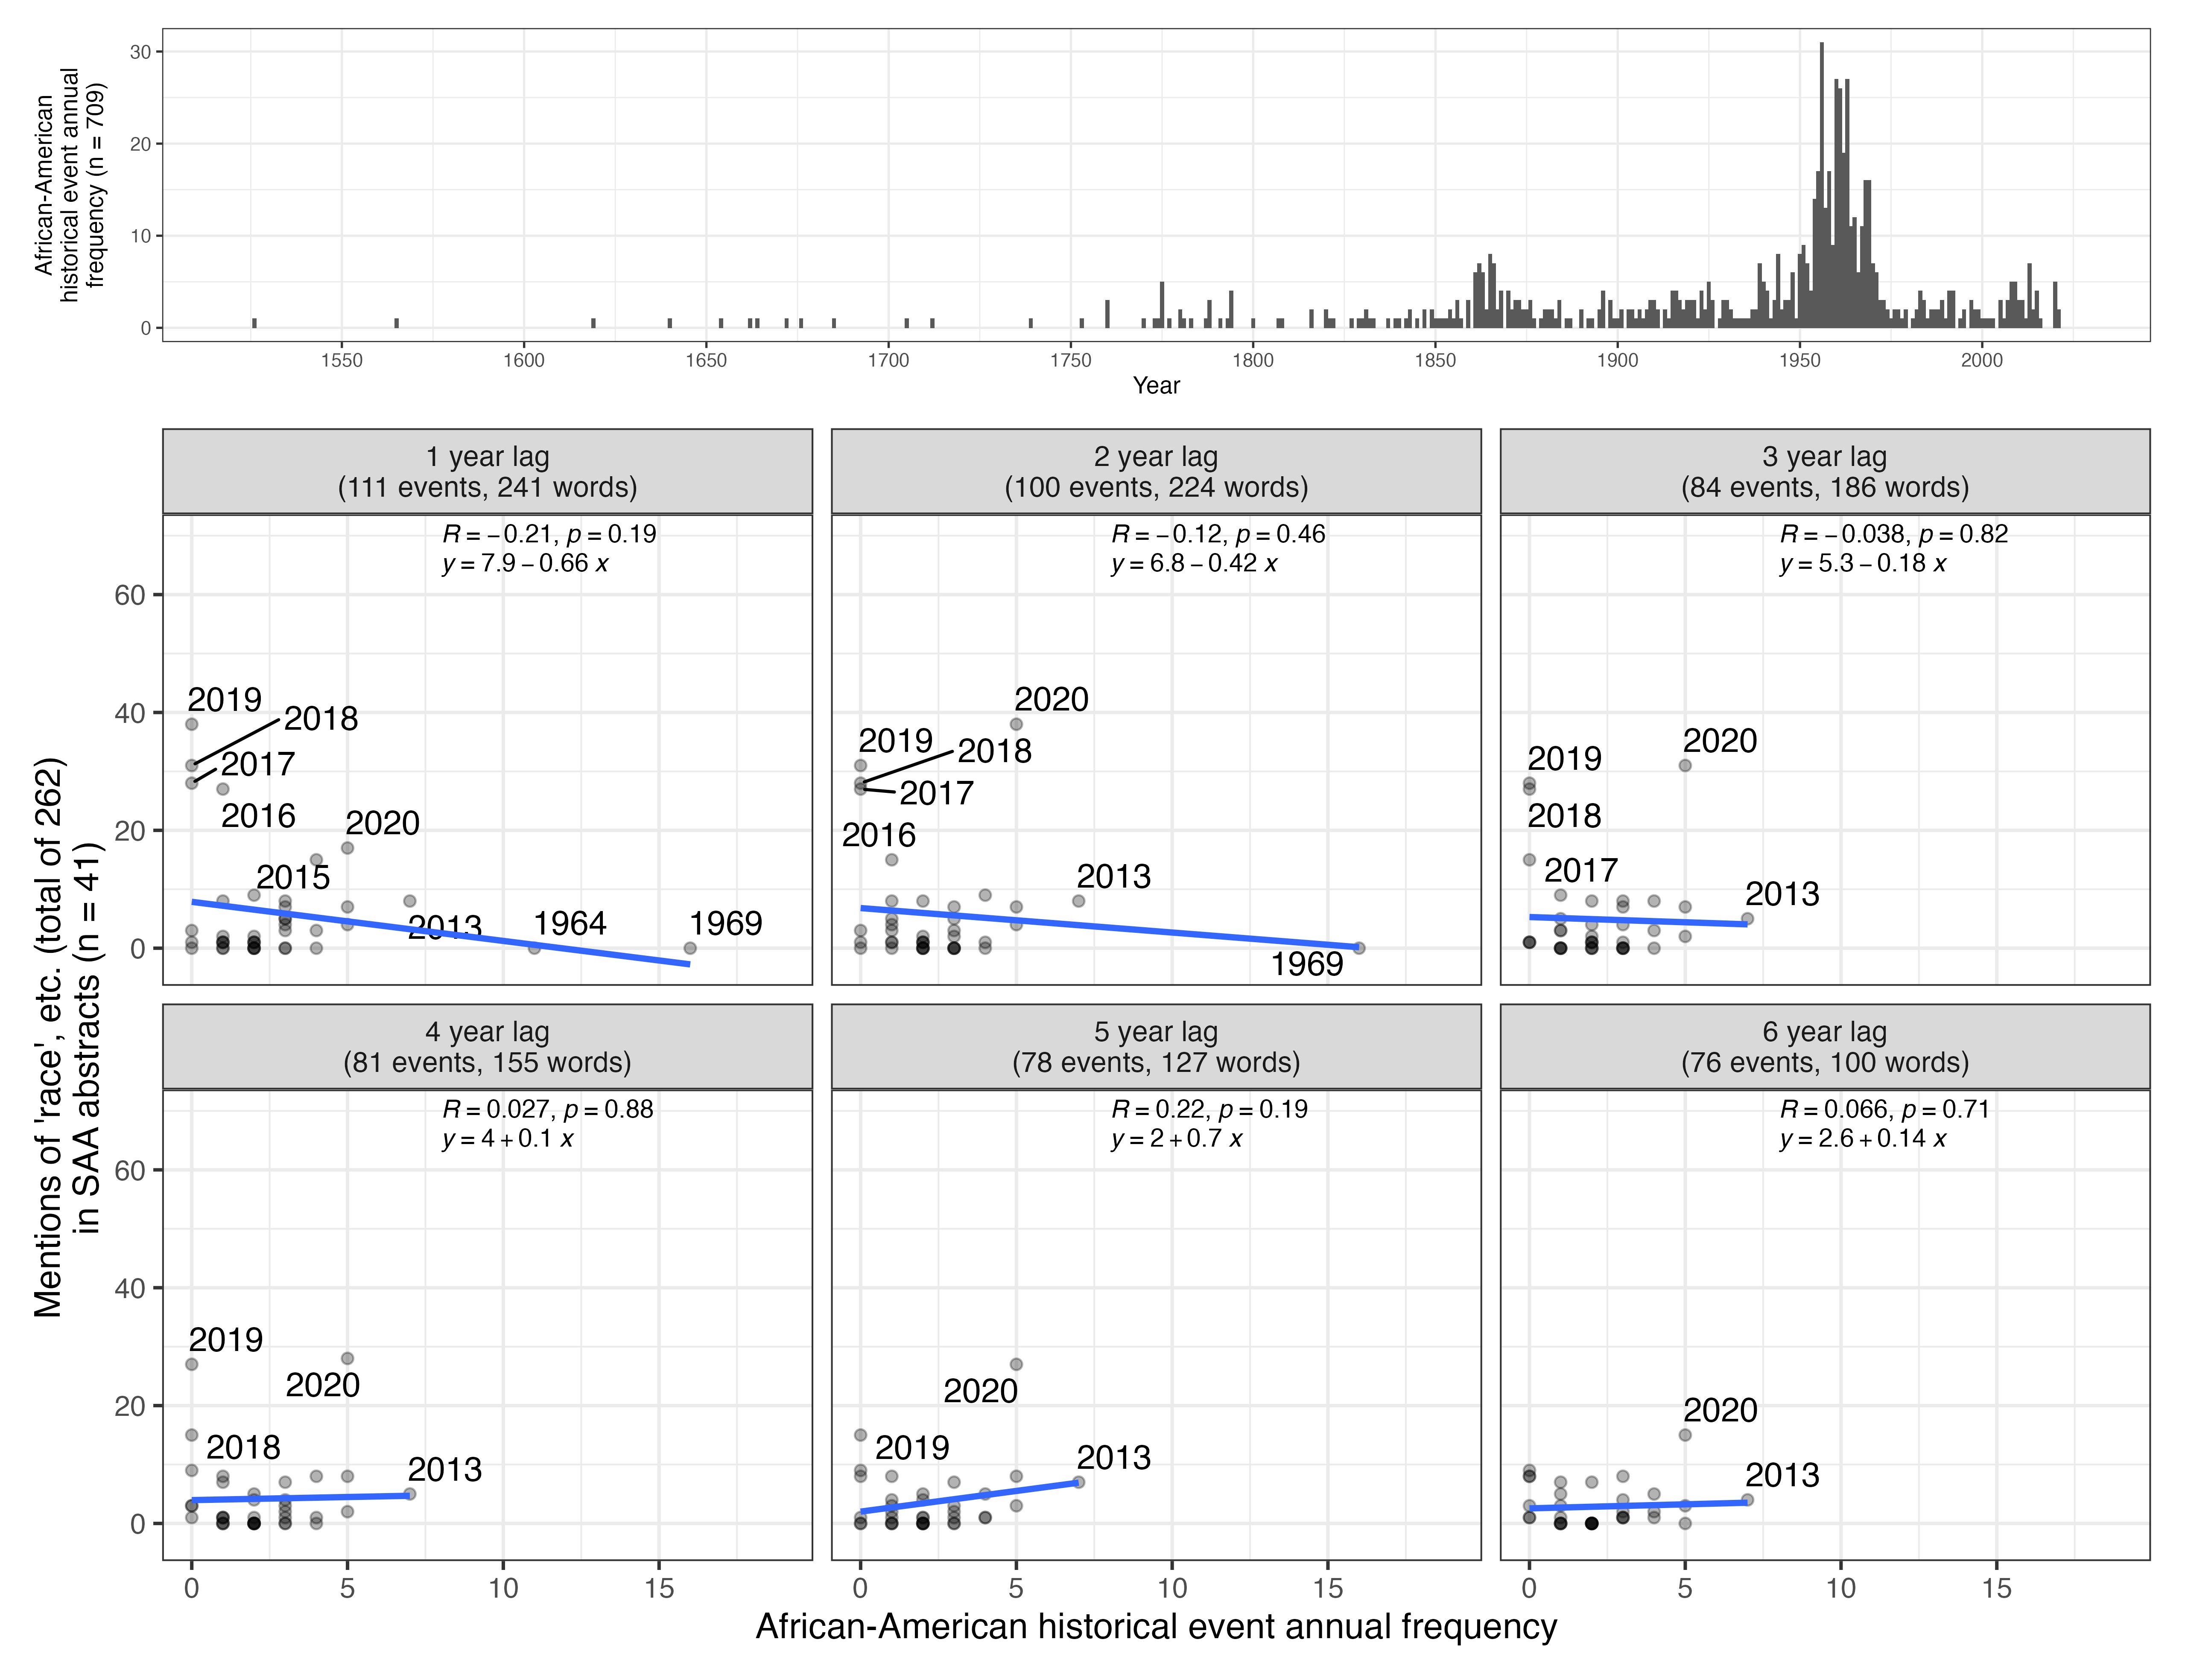

knitr::include_graphics(here::here("analysis/figures/006-ha-saa-boxplot.jpg"))

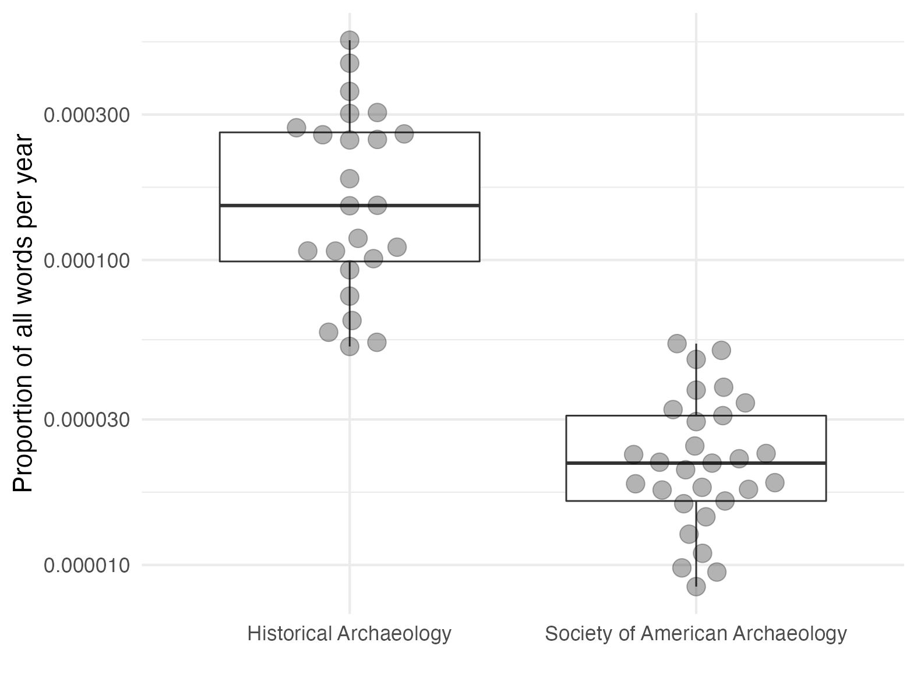

### 0.0.1 Colophon

This report was generated on 2021-06-20 10:27:15 using the following computational environment and dependencies:

# which R packages and versions?  
if ("devtools" %in% installed.packages()) devtools::session_info()  
#> ─ Session info ───────────────────────────────────────────────────────────────  
#> setting value   
#> version R version 4.0.5 (2021-03-31)  
#> os macOS Catalina 10.15.7   
#> system x86_64, darwin17.0   
#> ui X11   
#> language (EN)   
#> collate en_US.UTF-8   
#> ctype en_US.UTF-8   
#> tz America/Los_Angeles   
#> date 2021-06-20   
#>   
#> ─ Packages ───────────────────────────────────────────────────────────────────  
#> package * version date lib source   
#> assertthat 0.2.1 2019-03-21 [1] CRAN (R 4.0.0)  
#> backports 1.2.1 2020-12-09 [1] CRAN (R 4.0.2)  
#> bookdown 0.22 2021-04-22 [1] CRAN (R 4.0.2)  
#> broom 0.7.6 2021-04-05 [1] CRAN (R 4.0.2)  
#> cachem 1.0.5 2021-05-15 [1] CRAN (R 4.0.2)  
#> callr 3.7.0 2021-04-20 [1] CRAN (R 4.0.2)  
#> cellranger 1.1.0 2016-07-27 [1] CRAN (R 4.0.0)  
#> cli 2.5.0 2021-04-26 [1] CRAN (R 4.0.4)  
#> codetools 0.2-18 2020-11-04 [1] CRAN (R 4.0.5)  
#> colorspace 2.0-1 2021-05-04 [1] CRAN (R 4.0.2)  
#> crayon 1.4.1 2021-02-08 [1] CRAN (R 4.0.2)  
#> data.table 1.14.0 2021-02-21 [1] CRAN (R 4.0.2)  
#> DBI 1.1.1 2021-01-15 [1] CRAN (R 4.0.2)  
#> dbplyr 2.1.1 2021-04-06 [1] CRAN (R 4.0.2)  
#> desc 1.3.0 2021-03-05 [1] CRAN (R 4.0.4)  
#> devtools 2.4.1 2021-05-05 [1] CRAN (R 4.0.2)  
#> digest 0.6.27 2020-10-24 [1] CRAN (R 4.0.2)  
#> dplyr * 1.0.6 2021-05-05 [1] CRAN (R 4.0.2)  
#> ellipsis 0.3.2 2021-04-29 [1] CRAN (R 4.0.2)  
#> evaluate 0.14 2019-05-28 [1] CRAN (R 4.0.0)  
#> fansi 0.5.0 2021-05-25 [1] CRAN (R 4.0.2)  
#> fastmap 1.1.0 2021-01-25 [1] CRAN (R 4.0.2)  
#> fastmatch 1.1-0 2017-01-28 [1] CRAN (R 4.0.0)  
#> forcats * 0.5.1 2021-01-27 [1] CRAN (R 4.0.2)  
#> fs 1.5.0 2020-07-31 [1] CRAN (R 4.0.2)  
#> generics 0.1.0 2020-10-31 [1] CRAN (R 4.0.2)  
#> ggplot2 * 3.3.3 2020-12-30 [1] CRAN (R 4.0.2)  
#> glue 1.4.2 2020-08-27 [1] CRAN (R 4.0.2)  
#> gtable 0.3.0 2019-03-25 [1] CRAN (R 4.0.0)  
#> haven 2.4.1 2021-04-23 [1] CRAN (R 4.0.2)  
#> here 1.0.1 2020-12-13 [1] CRAN (R 4.0.2)  
#> highr 0.9 2021-04-16 [1] CRAN (R 4.0.2)  
#> hms 1.1.0 2021-05-17 [1] CRAN (R 4.0.2)  
#> htmltools 0.5.1.1 2021-01-22 [1] CRAN (R 4.0.2)  
#> httr 1.4.2 2020-07-20 [1] CRAN (R 4.0.2)  
#> igraph 1.2.6 2020-10-06 [1] CRAN (R 4.0.2)  
#> jpeg 0.1-8.1 2019-10-24 [1] CRAN (R 4.0.0)  
#> jsonlite 1.7.2 2020-12-09 [1] CRAN (R 4.0.2)  
#> knitr 1.33 2021-04-24 [1] CRAN (R 4.0.2)  
#> lattice 0.20-44 2021-05-02 [1] CRAN (R 4.0.2)  
#> lifecycle 1.0.0 2021-02-15 [1] CRAN (R 4.0.2)  
#> lubridate 1.7.10 2021-02-26 [1] CRAN (R 4.0.2)  
#> magrittr 2.0.1 2020-11-17 [1] CRAN (R 4.0.2)  
#> Matrix 1.3-3 2021-05-04 [1] CRAN (R 4.0.2)  
#> memoise 2.0.0 2021-01-26 [1] CRAN (R 4.0.2)  
#> modelr 0.1.8 2020-05-19 [1] CRAN (R 4.0.0)  
#> munsell 0.5.0 2018-06-12 [1] CRAN (R 4.0.0)  
#> pillar 1.6.1 2021-05-16 [1] CRAN (R 4.0.2)  
#> pkgbuild 1.2.0 2020-12-15 [1] CRAN (R 4.0.2)  
#> pkgconfig 2.0.3 2019-09-22 [1] CRAN (R 4.0.0)  
#> pkgload 1.2.1 2021-04-06 [1] CRAN (R 4.0.2)  
#> prettyunits 1.1.1 2020-01-24 [1] CRAN (R 4.0.2)  
#> processx 3.5.2 2021-04-30 [1] CRAN (R 4.0.2)  
#> ps 1.6.0 2021-02-28 [1] CRAN (R 4.0.4)  
#> purrr * 0.3.4 2020-04-17 [1] CRAN (R 4.0.0)  
#> quanteda * 3.0.0 2021-04-06 [1] CRAN (R 4.0.2)  
#> R6 2.5.0 2020-10-28 [1] CRAN (R 4.0.2)  
#> Rcpp 1.0.6 2021-01-15 [1] CRAN (R 4.0.2)  
#> RcppParallel 5.1.4 2021-05-04 [1] CRAN (R 4.0.2)  
#> readr * 1.4.0 2020-10-05 [1] CRAN (R 4.0.2)  
#> readxl 1.3.1 2019-03-13 [1] CRAN (R 4.0.2)  
#> remotes 2.3.0 2021-04-01 [1] CRAN (R 4.0.2)  
#> reprex 2.0.0 2021-04-02 [1] CRAN (R 4.0.2)  
#> rlang 0.4.11 2021-04-30 [1] CRAN (R 4.0.4)  
#> rmarkdown 2.8 2021-05-07 [1] CRAN (R 4.0.4)  
#> rprojroot 2.0.2 2020-11-15 [1] CRAN (R 4.0.2)  
#> rstudioapi 0.13 2020-11-12 [1] CRAN (R 4.0.2)  
#> rvest 1.0.0 2021-03-09 [1] CRAN (R 4.0.2)  
#> scales 1.1.1 2020-05-11 [1] CRAN (R 4.0.0)  
#> sessioninfo 1.1.1 2018-11-05 [1] CRAN (R 4.0.0)  
#> stopwords 2.2 2021-02-10 [1] CRAN (R 4.0.2)  
#> stringi 1.6.2 2021-05-17 [1] CRAN (R 4.0.2)  
#> stringr * 1.4.0 2019-02-10 [1] CRAN (R 4.0.0)  
#> tarchetypes 0.2.0 2021-05-11 [1] CRAN (R 4.0.2)  
#> targets * 0.4.2 2021-04-30 [1] CRAN (R 4.0.2)  
#> testthat 3.0.2 2021-02-14 [1] CRAN (R 4.0.2)  
#> tibble * 3.1.2 2021-05-16 [1] CRAN (R 4.0.2)  
#> tidyr * 1.1.3 2021-03-03 [1] CRAN (R 4.0.2)  
#> tidyselect 1.1.1 2021-04-30 [1] CRAN (R 4.0.4)  
#> tidyverse * 1.3.1 2021-04-15 [1] CRAN (R 4.0.2)  
#> usethis 2.0.1 2021-02-10 [1] CRAN (R 4.0.2)  
#> utf8 1.2.1 2021-03-12 [1] CRAN (R 4.0.2)  
#> vctrs 0.3.8 2021-04-29 [1] CRAN (R 4.0.2)  
#> withr 2.4.2 2021-04-18 [1] CRAN (R 4.0.2)  
#> xfun 0.23 2021-05-15 [1] CRAN (R 4.0.2)  
#> xml2 1.3.2 2020-04-23 [1] CRAN (R 4.0.0)  
#> yaml 2.2.1 2020-02-01 [1] CRAN (R 4.0.0)  
#>   
#> [1] /Library/Frameworks/R.framework/Versions/4.0/Resources/library

The current Git commit details are:

# what commit is this file at?   
if ("git2r" %in% installed.packages() & git2r::in_repository(path = ".")) git2r::repository(here::here())   
#> Local: master /Users/bmarwick/Desktop/bulletinracisminarchy  
#> Remote: master @ origin (https://github.com/parkgayoung/bulletinracisminarchy)  
#> Head: [aea8f7c] 2021-06-19: rethink the trigrams analysis